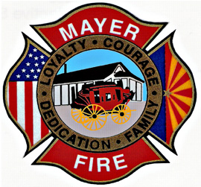

Mayer Fire District Testing Dates

* May 4th - Application close date
* May 19th – Written test @ 0900 at Mayer Fire Admin building
* June 2nd and 3rd (if needed) – 1st round interviews starting @ 0830 at Mayer Fire Admin building
* June 9th and 10th (if needed) – 2nd round interviews starting @ 0830 at Mayer Fire Admin building
* June 23rd, 24th, 30th, and July 1st- Orientation days starting @ 0800 at Mayer Fire Admin building (these days are mandatory attendance)
* **Note: All dates are tentative and subject to change**