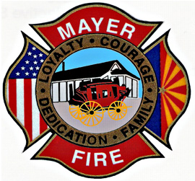

Level 1
Fire Restrictions

Mayer Fire District
June 1, 2017
10:30AM

- NO burn permits will be issued

- NO burning will be allowed on existing burn permits

- Cooking and/or warming fires are allowed at single and multi-family residences and county parks (where approved) but MUST BE attended at all times

- Persons conducting outside welding, cutting or grinding operations must have a fire extinguisher or charged water hose near all operations at all times

- Level 1 restrictions will remain in place until removed by the Mayer Fire District

Mayer Fire is an equal opportunity provider and employer

