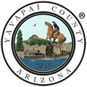 | 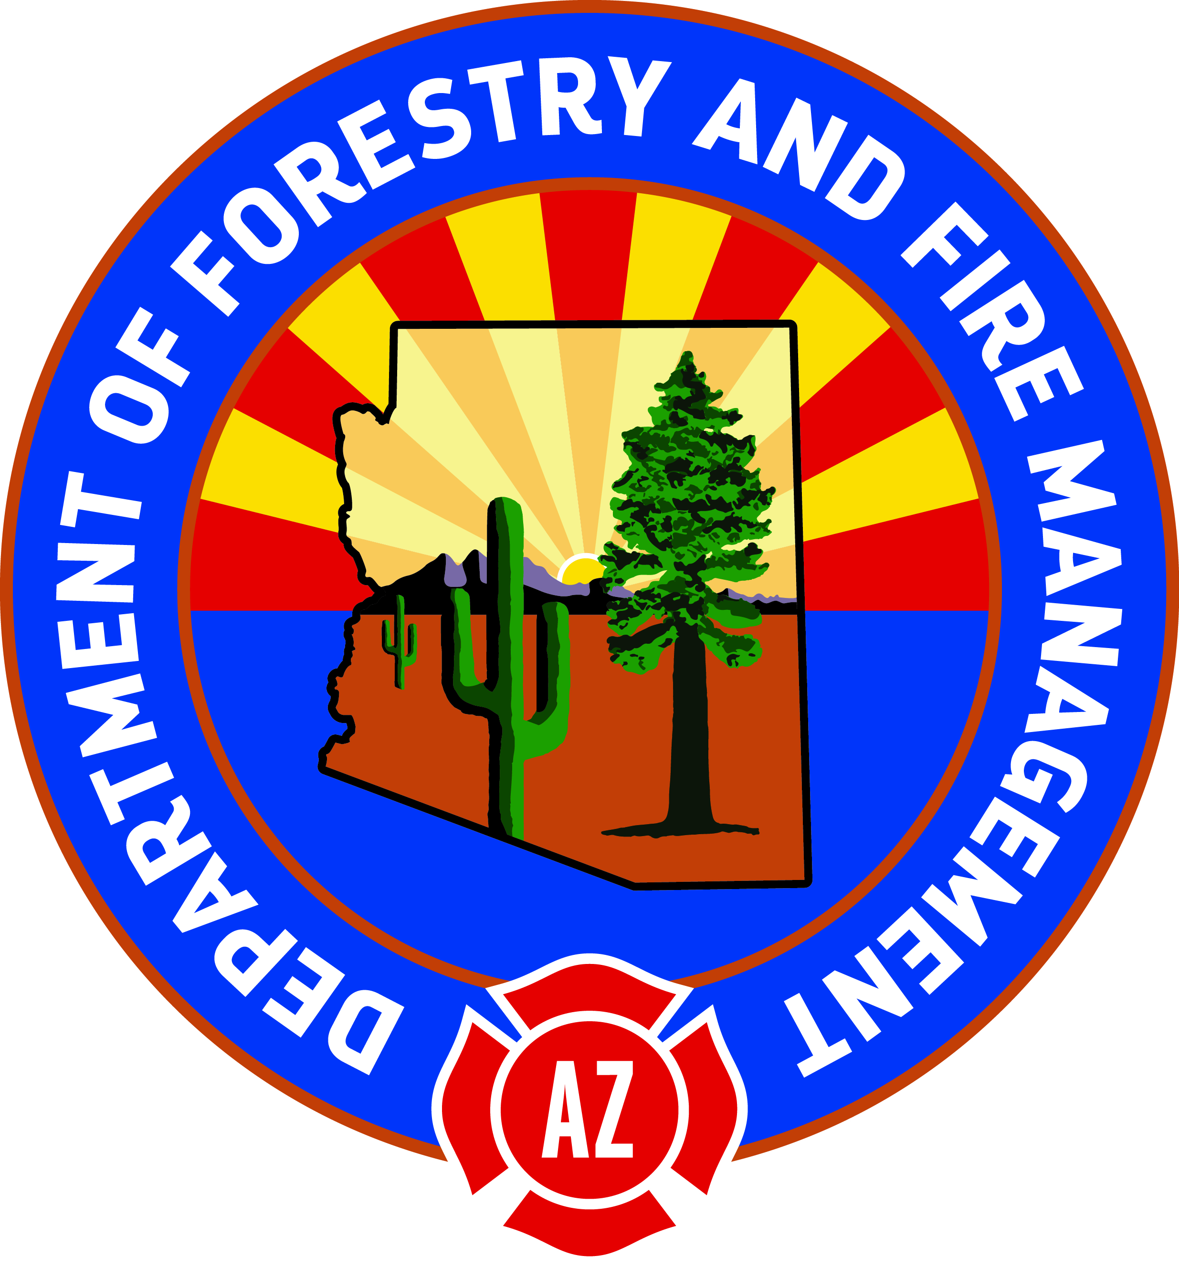 | 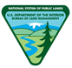 |  | 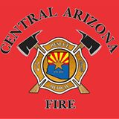 | 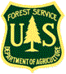

NEWS RELEASE
http://wildlandfire.az.gov
FOR IMMEDIATE RELEASE Contact: Southwest Fire Restrictions Hotline 1-877-864-6985

Fire Restrictions Lifted Monday, July 17th

FOR IMMEDIATE RELEASE (July 16, 2017) – A coordinated decision has been made to lift fire restrictions across lands with similar conditions. As of Monday, July 17th at 12:00 p.m., fire restrictions will be lifted across the following jurisdictions:

- Prescott National Forest;
- Yavapai County;
- Bureau of Land Management – Phoenix District;
- Arizona State Department of Forestry and Fire Management – NW District;
- Lands serviced by Central Arizona Fire and Medical Authority (CAFMA- the former Central Yavapai and Chino Valley Fire Districts) which includes the Town of Chino Valley, Paulden and the areas surrounding the City of Prescott such as Williamson Valley, upper Copper Basin Road and Mountain Club area, Ponderosa Park off of White Spar Road, the Senator Highways area of Karen Drive, Sweet Acres, and Oak Knoll Village and finally the areas extending south of Prescott including Govt. Canyon, Diamond Valley, the Town of Prescott Valley and the Town of Dewey/Humboldt;
- And all lands serviced by the City of Prescott Fire Department.

Coordination regarding this decision also included discussions with the Kaibab and Coconino National Forests in northern Arizona; the Tonto National Forest; and the US Fish and Wildlife Service. Decisions and timelines regarding the lifting of fire restrictions on lands administered by these agencies are likely close or will coincide with the decision noted above. However, visitors are encouraged to check the conditions and fire restrictions status on those lands.

“Despite some significant rain storms over the past week, we hadn’t seen enough rain across enough of the area to feel comfortable lifting the fire restrictions. However, this weekend brought about quite a bit of rain in many areas and the forecast calls for a dramatic increase in rain chances across most of the state in the next few days. The conditions are changing dramatically and rapidly reducing the threat of any significant fire behavior” – Pete Gordon, Fire Chief – Prescott National Forest

Prescott National Forest and our Inter-Agency Partners would like thank our local neighbors and forest visitors for their cooperation in preventing wildfires. While all fire restrictions will be lifted on Monday, everyone is reminded that the potential for wildfires still exist and to please use caution with campfires and other potential ignition sources. It is also important to pay attention to the monsoon weather where rain storms can cause flash-flooding and dangerous conditions can quickly arise several miles down-stream from the storm.

For a more detailed explanation concerning agency restrictions and fire information in general, please contact the nearest land management agency office where you plan to work or play, visit http://wildlandfire.az.gov or call the toll free Southwest Fire Restrictions Hotline 1-877-864-6985. The direct fire restrictions information website for Arizona is http://firerestrictions.us/az.

