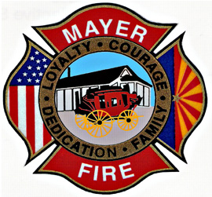
_____________________________________________________________________________________________
Two Open Positions on the Mayer Fire District Governing Board of Directors
______________________________________________________________________________

The Mayer Fire District is accepting letters of interest to fill two open Board Member positions. Interested parties must be qualified voters that live within the Mayer Fire District.
Email information to sowen@mayerfire.com or, submit it to Mayer Fire District 11975 S. State Route 69, Mayer, AZ 86333 by 5PM Wednesday, January 16, 2019.
For additional information please call 928-632-9534.
The Board is scheduled to interview those interested at the Board Meeting on January 16, 2019.

Mayer Fire is an equal opportunity provider and employer

