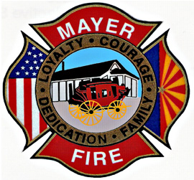
Mayer Fire District
11975 S. State Route 69
Mayer, AZ 86333

928-632-9534 / Emergency: 911

Stage I Fire Restrictions: August 10, 2020

- NO burn permits will be issued
- Use of model rockets is PROHIBITED
- Use of fireworks and other pyrotechnic displays are PROHIBITED except by commercial special events permit
- NO smoking outside of vehicles, outside of residential yards, or outside of designated smoking areas
- Cooking, warming, or camp fires ARE still ALLOWED at single and multi-family residences and parks (where approved) but MUST BE attended at all times

Stage II Fire Restrictions: August 10, 2020

- NO burn permits will be issued
- Use of model rockets is PROHIBITED
- Use of fireworks and other pyrotechnic displays are PROHIBITED except by commercial special events permit
- NO smoking outside of vehicles, outside of residential yards, or outside of designated smoking areas
- Welding, cutting, grinding and chain saw use is PROHIBITED (Permission may be granted under special circumstances and repair situations as approved by the Fire Chief)**
- Warming fires and camp fires are PROHIBITED in single and multi-family residences and parks. This also prohibits the use of other devices that produce open flame such as tiki lamps.
- The use of propane, natural gas or other gas flame-producing barbeque cooking grills MAY BE USED at single and multi-family residences as long as they are constantly attended and are in an enclosed device.

** Certain activities including welding, cutting, grinding, chainsaw use, (any spark/flame producing activity) outdoors shall require the following:
o A Fire Department Permit for a specific time period, location, and activity granting permission to conduct such activity in a safe manner.
o A fire watch, an individual for the sole purpose watching for any sparks and/or ignition.
o Firefighting tool(s) such as a shovel.
o Approved water supply available from a hose, water truck, etc.

